How to Set Up Web Scraping Environment

- If you haven’t installed Chrome browser yet, download and install Chrome from here (https://www.google.com/intl/en_ca/chrome/).
- If Chrome is already installed on your computer, check its version. Ensure you upgrade to the latest version before moving on to the next step. Refer to the following example to check your current version of Chrome.
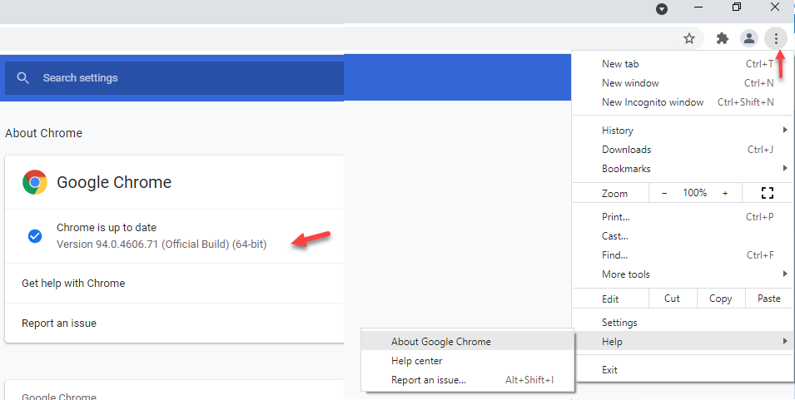

- Download Chromedriver from here, https://googlechromelabs.github.io/chrome-for-testing/#stable

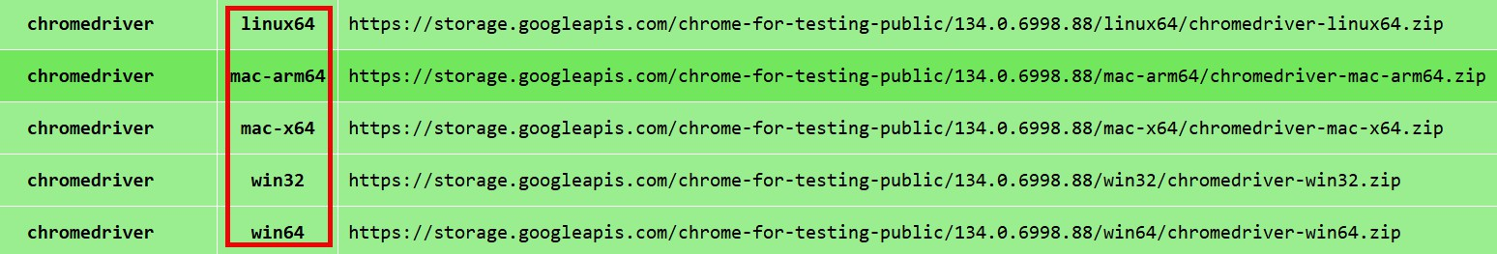

Note: Double-check your Chrome edition and OS edition. If you're using macOS, you need to download the mac-x64 version. If your CPU is M2 or above, you must download the mac-arm64 version.
- Based on the version of your Chrome, download your chromedriver. For example, if you use chrome 134.0.4606.7, download the chromeDriver 134.0.460
- Check your download folder and extract the file.
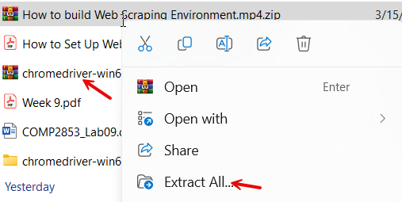
- Copy the unzipped file to your C drive. Create a folder such as C:\python\ChromeDrive
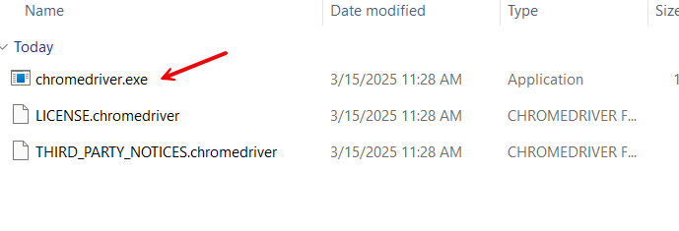

- Create a folder such as C:\python\ChromeDrive
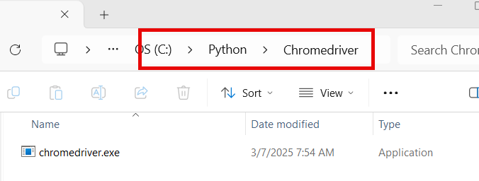

- Start your Chrome and open the Chrome Web Store by using your Chrome browser (https://chrome.google.com/webstore/category/extensions)
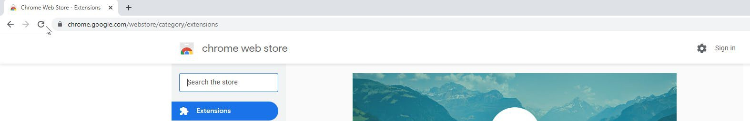
- Search the selector gadget
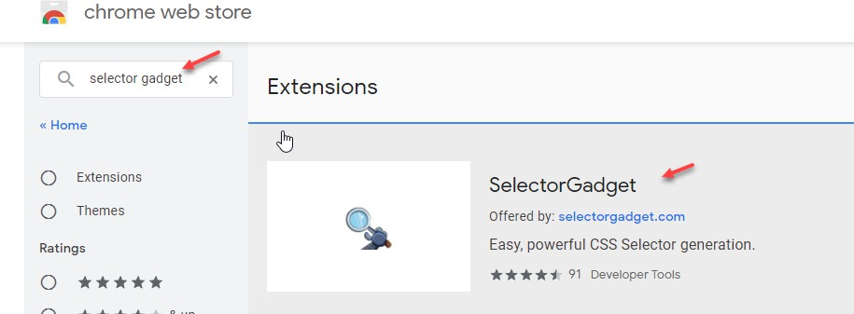
- Click Add to Chrome
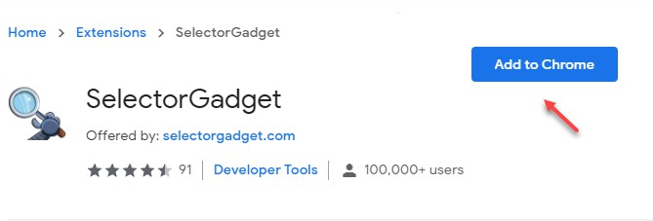
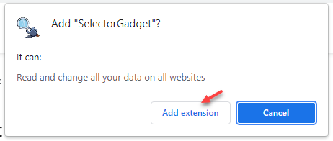

- If you want to use the selector gadget, click extensions and then select the Selector Gadget
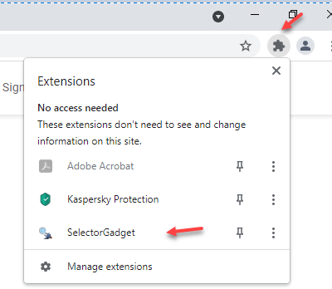
- Run you Pycharm and install the following libraries: pandas, selenium, lxml, bs4 and webdriver-manager.
- Copy the following code and paste the code on your PyCharm. Note: Double-check the highlighted content. Make sure to use the path of your chromedriver.exe location.
from selenium import webdriver
from webdriver_manager.chrome import ChromeDriverManager
from selenium.webdriver.chrome.service import Service
DRIVER_PATH = "/Python/ChromeDriver/chromedriver.exe"
browser = None
# This loads webdriver from the local machine if it exists.
try:
browser = webdriver.Chrome(service=Service(DRIVER_PATH))
print("The path to webdriver_manager was found.")
# If a webdriver not found error occurs it is then downloaded.
except:
print("webdriver not found. Update 'DRIVER_PATH' with file path in the download.")
browser = webdriver.Chrome(ChromeDriverManager().install())

14. After running the code in PyCharm, you should see the following output:
